P2 references

**jQuery**

Dialog box position

<https://api.jqueryui.com/position/>

<https://jqueryui.com/dialog/>

**What I did to make jQuery x button work, with my customized jQuery ui theme**

I downloaded the basic css theme: <https://code.jquery.com/ui/1.12.1/themes/base/jquery-ui.css> (saved as jquery-ui.css)

Then placed in my css folder

Then in index.html, linked stylesheet:

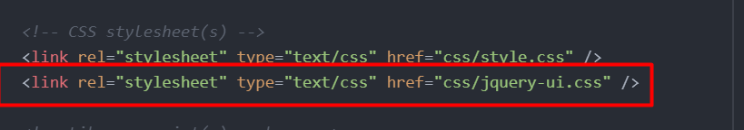

Then realized unfortunately I don’t have the images for the icons, so I downloaded a random themeroller just to copy-paste the images into my assets folder:

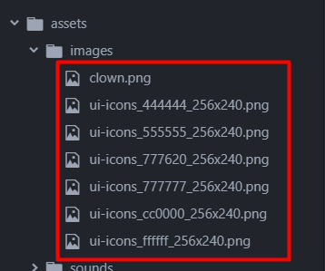

Then in my jquery-ui.css, I had to find where the images were (ctrl+f 🡪 “icons”), and link them properly from my assets folder:

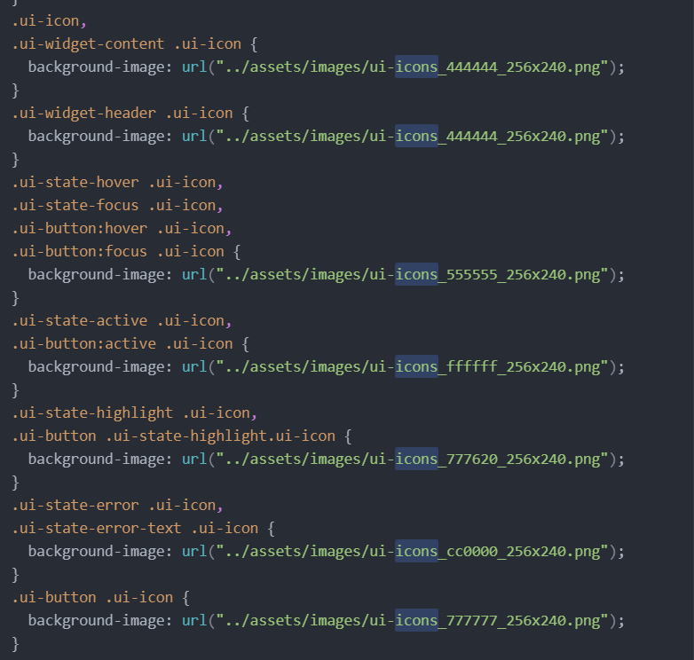

^^I renamed link to “…/assets/blah-blah”

It should work now.

How to customize dialog box

<http://www.w3big.com/jqueryui/jqueryui-custom.html>

Example of jquery and p5.js

<https://pippinbarr.github.io/cart263-2021/examples/jquery-ui/jquery-with-p5/>

<https://github.com/pippinbarr/cart263-2021/blob/main/examples/jquery-ui/jquery-with-p5/index.html>

<https://github.com/pippinbarr/cart263-2021/blob/main/examples/jquery-ui/jquery-with-p5/js/script.js>

UI effects

<https://api.jqueryui.com/category/effects/>

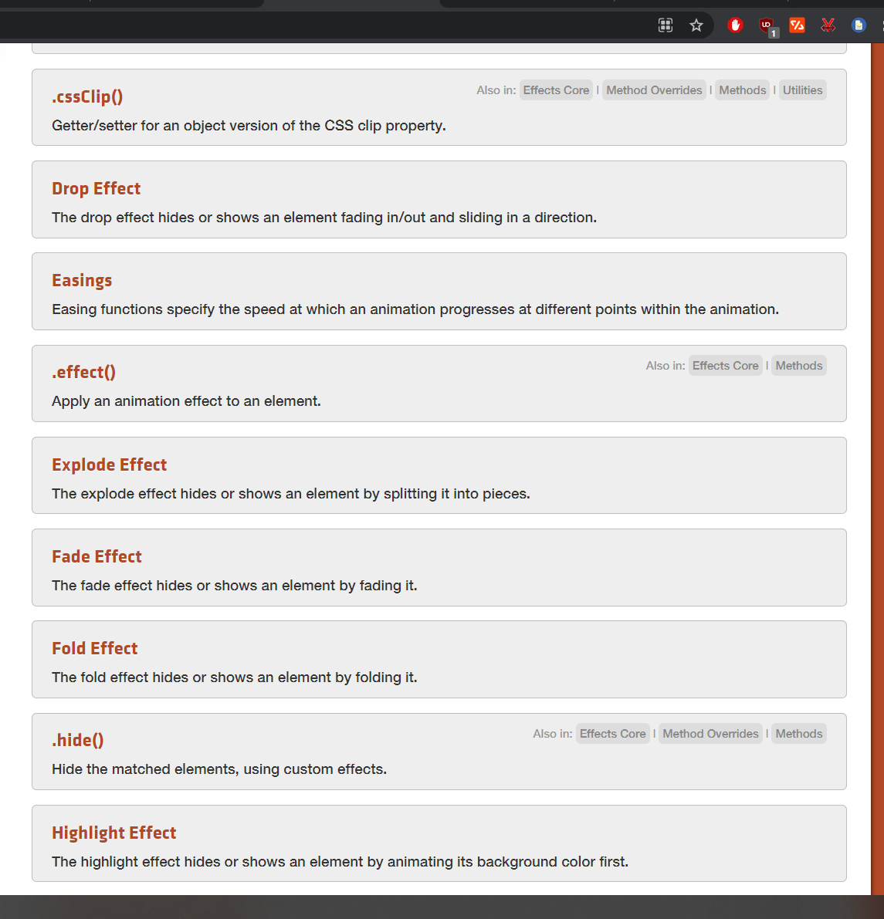

Dynamically changing text in dialog button:

<https://stackoverflow.com/questions/4591642/dynamically-changing-jquery-ui-dialog-box-button-text/53078412>

(next page)

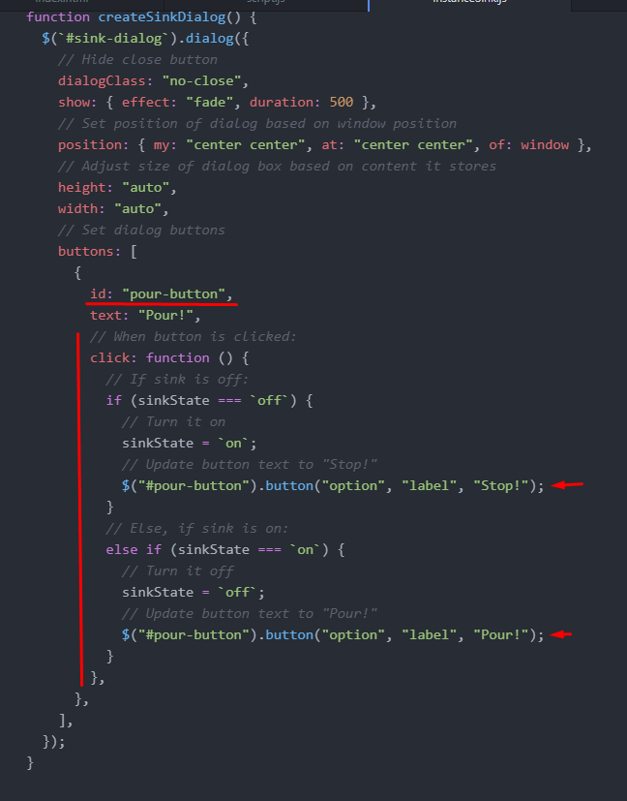

Switch button label:

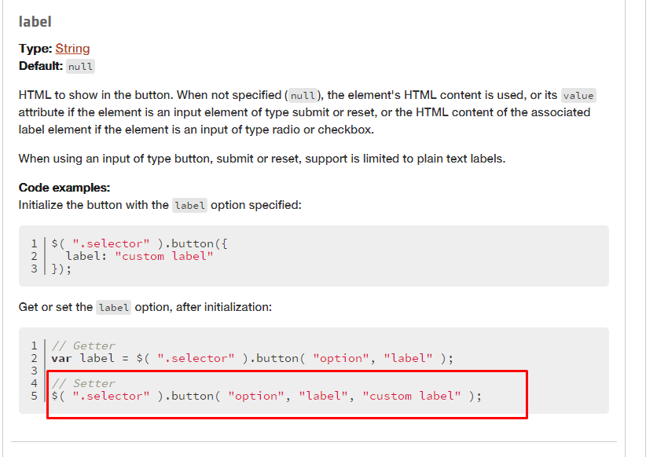

How to customize a specific dialog box

<https://stackoverflow.com/questions/17386839/custom-style-to-jquery-ui-dialogs>

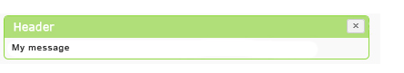

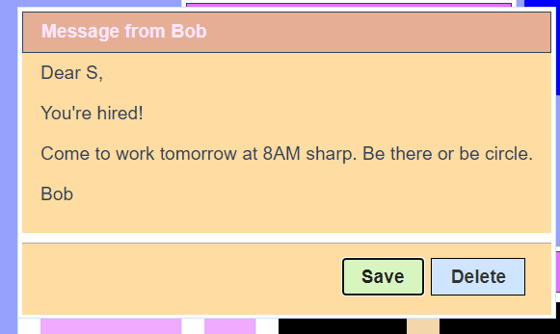

My code:

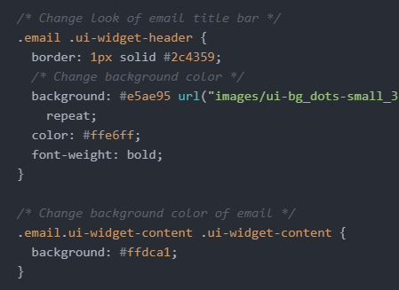

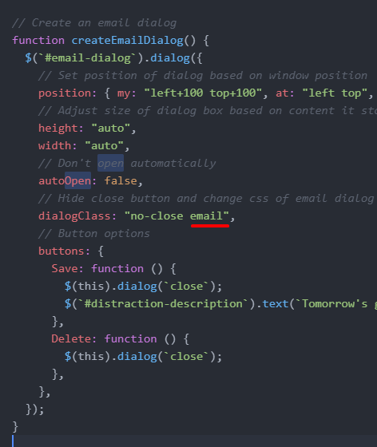

Make canvas fade away using jQuery UI effects:

<https://api.jqueryui.com/toggle/>

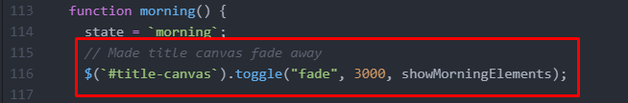

Remove border of ui-dialog:

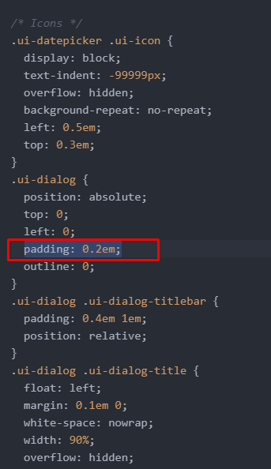

**p5.js**

Video capture

<https://p5js.org/examples/dom-video-capture.html>

Instance

<https://p5js.org/reference/#/p5/p5>

<https://p5js.org/examples/instance-mode-instantiation.html>

**p5.sound**

Looping sound

<https://p5js.org/reference/#/p5.MediaElement/loop>

Looping sound in instance mode

https://discourse.processing.org/t/how-to-use-sound-in-p5-js-instance-mode/25999

**JavaScript**

Sound: play audio:

<https://developer.mozilla.org/en-US/docs/Web/API/HTMLAudioElement>

